
GRIDNODE PTE LTD

GRIDTALK™
GridTalk Installation Guide
for SunOS

Release version 4.0

Document Updated : 11 December 2006

Copyright

© Copyright 2006 GRIDNODE PTE LTD. All rights reserved.

No part of this GridTalk™ installation guide may be reproduced or transmitted in any form or for any purpose without the express permission of GRIDNODE PTE LTD. The information contained herein may be changed without prior notice.

GRIDNODE PTE LTD further does not warrant the accuracy or completeness of the information, text, graphics, links, or other items contained within these materials. GRIDNODE PTE LTD shall not be liable for any special, indirect, incidental, or consequential damages, including without limitation, lost revenues or lost profits, which may result from the use of these materials. The information in this documentation is subject to change without notice and does not represent a commitment on the part of GRIDNODE PTE LTD for the future.

Some software products marketed by GRIDNODE PTE LTD and its distributors contain proprietary software components of other software vendors.

Names of all products herein are used for identification purposes only and are trademarks and/or registered trademarks of their respective owners.

GridTalk™, and GridNode™ are registered or unregistered trademarks of GRIDNODE PTE LTD.

All rights reserved.

GridTalk™
GridTalk Installation Guide

Contents

Chapter Page

1. About this GridTalk 4.0 Installation Guide 1
1.1. Related Documentation 1
1.2. Typographical conventions 2
2. System requirements 3
2.1. Pre-Setup 3
3. Installation GridTalk 4.0 4
3.1. To download and install GridTalk 4.0 for the first time 4
3.2. Running GridTalk 4.0 10
3.2.1. Starting GridTalk 4.0 10
3.2.2. Shutting down GridTalk 4.0 13
4. Maintenance of GridTalk 4.0 14
4.1. To uninstall GridTalk 14
4.2. To re-install GridTalk 16

About this GridTalk 4.0 Installation Guide

The GridTalk 4.0 Installation Guide covers the installations such as:

- GridTalk 4.0 software is distributed as a SH file for Sun OS.

- The installation should be done using InstallAnywhere. InstallAnywhere is an easy-to-use installer that deploys and configures GridTalk automatically on any platform.

Take note that your vendor or system integrator will provide you the correct information for the Product Registration and connection level configuration. This information is unique to your copy of GridTalk 4.0 and necessary for the proper functioning of the software.

Related Documentation
The following documents directly support GridTalk:
- GridTalk 4.0 Administration Guide
- GridTalk 4.0 User Guide

Typographical conventions

The guide uses the following typographical conventions for Windows users.

Convention |  | Example
Procedures are described as a series of numbered steps. |  | - Click the Create icon on the main toolbar.  - Click the Browse button.
Variable information that you must type based on your specific situation is shown in italics. |  | Type /usr/local/bin/Gridnode in the field provided.

System requirements

The recommended system requirements for GridTalk 4.0 are:

For Sun Unix operating system,
- CPU: AMD-64bit, or Sparcv9 (64-bit), 2.0 GHz
- RAM: 1GB
- Hard disk: 5GB
- Solaris 10 Operating System
- Mozilla 1.7, FireFox 1.5 or above for browser

Pre-Setup

Before setting up GridTalk4.0, you have to ensure that the following checks be done accordingly:

- The ports used by GridTalk are described as tabulated below. Check that they are not used by other active applications:

Port used | Purpose
31098 | Listening port Java RMI Naming service used by the EJB application server.
31099 | Listening port for Java Naming Service used by the EJB application server.
3306 | MySQL access port. Local access only.
9099 | GridTalk Console port
8080 | RosettaNet HTTP port
443 | RosettaNet HTTPS port
8009 | AJP connection port (for connection to Apache server)
6763 | GridTalk backend connector listening port
6767 | Backend Receiver listening port. Used for backend configuration if applicable
5001 | GridTalk Backend Webservice monitoring port
4444 | Internal JBoss port (RMI)
4445 | Internal JBoss port (Pool management)
8083 | Internal JBoss port (Web services)
12345 | Listening port for logging events.

Installation GridTalk 4.0

GridTalk 4.0 should be installed on a server or PC with Internet access. (See 2.1 for the minimum and suggested system and hardware requirements.)

To download and install GridTalk 4.0 for the first time

After you have downloaded the installer files from the CD-ROM distributed to you, ensure that you have GridTalk 4.0 installer for the installation process. The following installer files are available for the two supported platforms:
- AMD-64bit: GridTalk4.0.2_jBoss_solaris_amd64.sh
- Sparcv9: GridTalk4.0.2_jBoss_solaris_sparcv9.sh

Take note that your vendor will provide you with your node information like GridNode Name, GridNode ID, License Key, etc.

- Double click on the installer file saved on your computer to begin the installation process. You may have to change the file permissions to enable execution on the file. Wait a few moments while the InstallAnywhere extract the installation package:

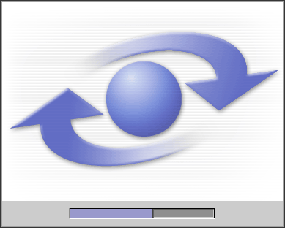

- You will be greeted by this Welcome window like this:

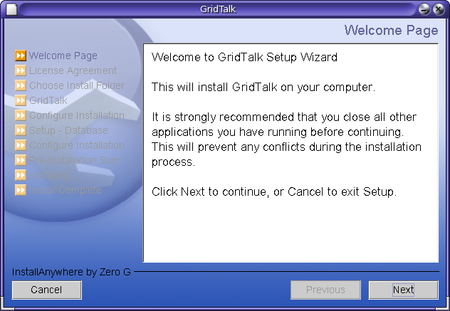

- Click Next to install GridTalk 4.0. Then you will be prompted to read and accept the License Agreement. To accept the terms of the License agreement, click on its radio button. Click Next.

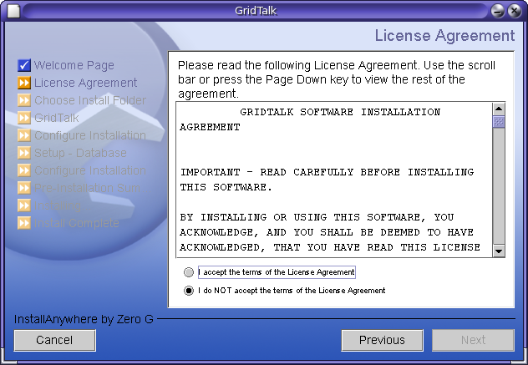

- As the Choose Install Folder window appears, select the destination folder to install GridTalk 4.0. Alternatively, click Choose Folder to select the destination folder you want. Once you are finished with creating that folder, proceed to click Next.

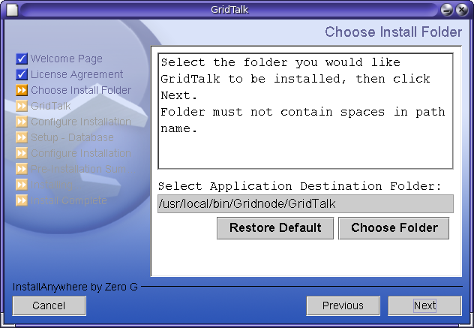

Take note that if you already have the existing GridTalk before installing it, you will be prompted by this screen below to notify you.

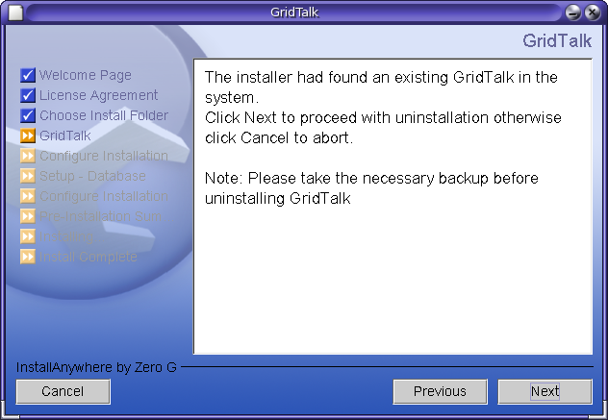

Click Next to proceed with the un-installation of previous GridTalk version.

- The Configure Installation appears. If this is the first time you are installing GridTalk 4.0, just proceed to click Next again. Take note that the Install MySQL 5.0 checkbox is ticked by default.

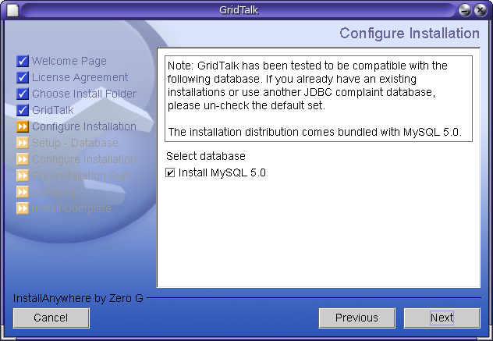

- The Pre-Installation Summary window appears, showing you the summary of your installation settings. Click Install to start the installation.

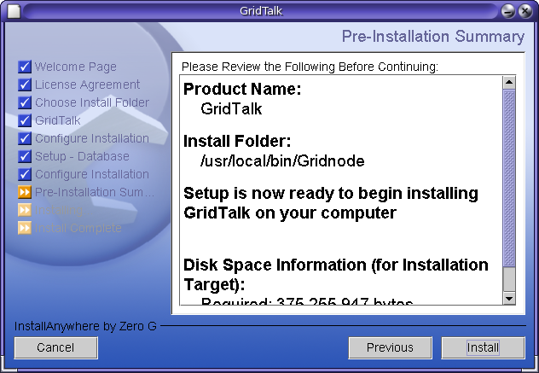

- As the installation begins, InstallAnywhere deploys the main applications such as Java Runtime Environment, JBoss, Ant, etc.

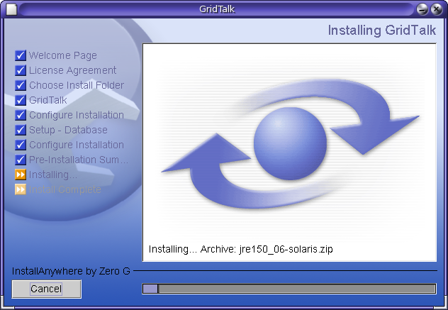

- Once the GridTalk 4.0 is successfully installed, click Done to finish the installer.

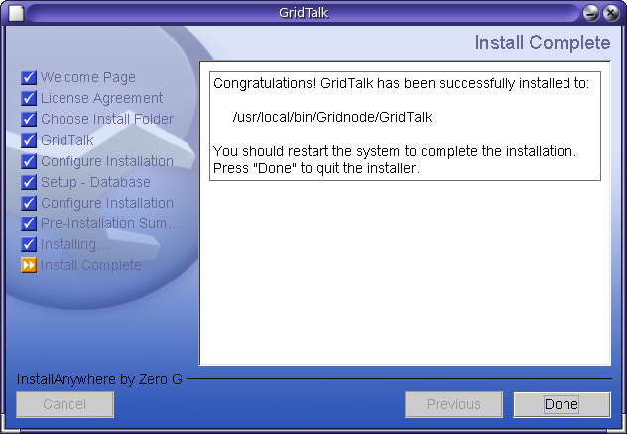

- At the end of installation process, the GridTalk desktop shortcut folder will be created to contain its contents as shown below.

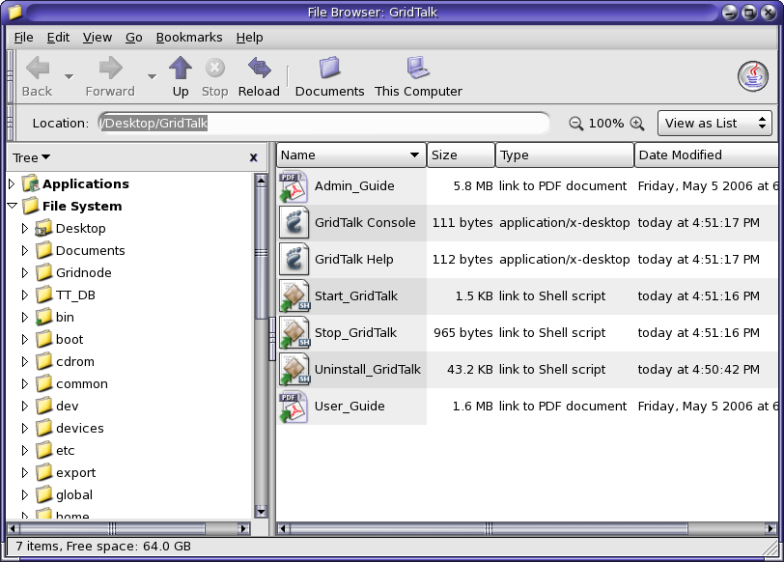

The shortcut icons serve the following purposes:

Shortcut icon name | Purpose
Start_GridTalk | To startup the GridTalk application.
Stop_GridTalk | To shutdown the GridTalk application.
GridTalk Console | To launch the GridTalk Console webpage on the system default Internet browser.
GridTalk Help | To laucn the GridTalk Online Help webpage on the system default internet browser.
User_Guide | To open up the GridTalk User Guide in the system pre-installed Adobe Acrobat Reader.
Admin_Guide | To open up the GridTalk Administration Guide in the system pre-installed Adobe Acrobat Reader.
Uninstall_GridTalk | To start the uninstallation wizard for GridTalk.

- Proceed to the next chapter for details on using the GridTalk application.

Running GridTalk 4.0

After GridTalk 4.0 has been successfully installed, you may proceed to startup the application for first-time product registration and configuration.

Starting GridTalk 4.0

Before starting up GridTalk 4.0, make sure that the GRIDTALK_HOME environment variable is correctly pointing to the installed folder.

- To start GridTalk 4.0 for the first time, the first step is to go to the Desktop and open up the GridTalk folder.

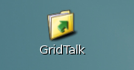

- From the various shortcut icons listed, double-click Start_GridTalk. You may be prompted for the manner of running startup script, as follows:

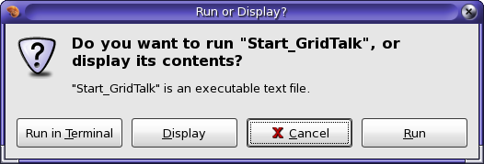

- Select “Run in Terminal” to start the application in the foreground, otherwise, select “Run” to run the application in the background. If you run the application in the foreground, you will be able to see the progress of starting up GridTalk in the terminal window:

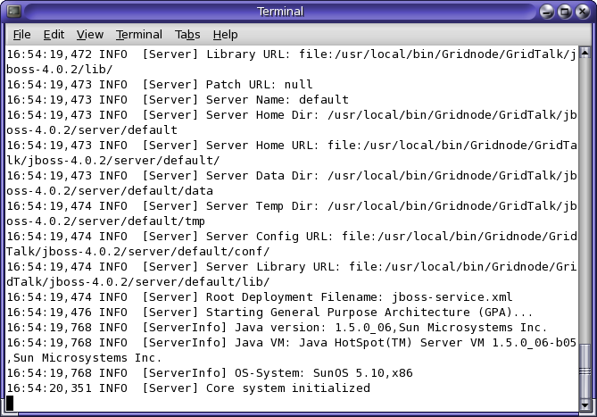

Note that you should not close the terminal while GridTalk is running as it would stop the application abnormally.

If you start GridTalk in the background, you would need to monitor the JBoss server log file ($GRIDTALK_HOME/jboss-4.0.2/server/default/log/server.log) for the “Started in ##m:##s:##ms” message. If GridTalk is started in the foreground, you may see this same message in the terminal window, as well as the “Application Server startup successful” message:

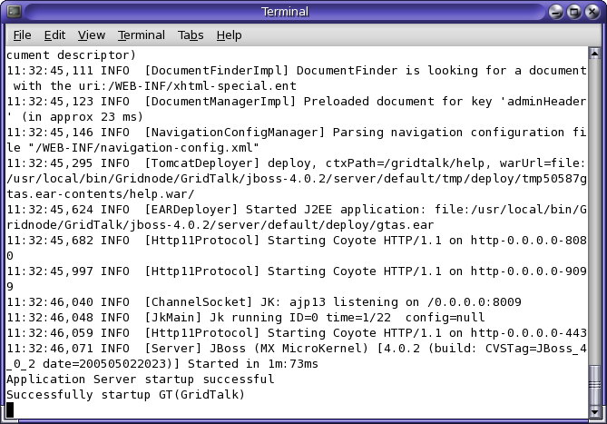

For a system configuration similar to the recommended configuration (section 2.1), the startup time takes about 1 minute or less.

- Go to the GridTalk folder on the Desktop, and double-click the “GridTalk Console” shortcut icon. This will open up your default internet browser and go to this website address:

http://localhost:8080/gridtalk

Take a few moments to wait until the GridTalk application browser appears like this:

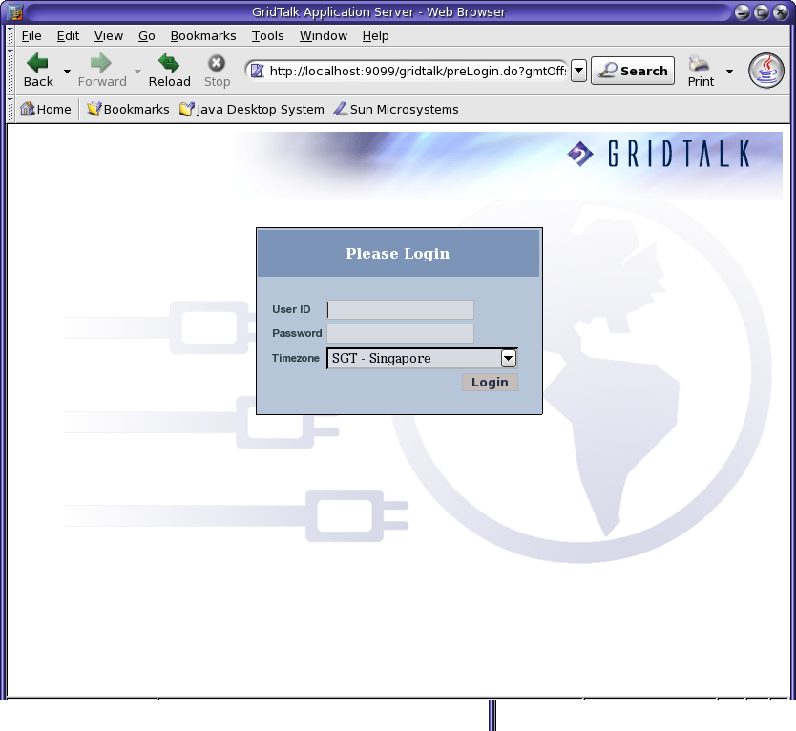

- To log into GridTalk for the first time, enter user name and password. For the first-time registration, refer to GridTalk 4.0 Administrator Guide.

Shutting down GridTalk 4.0

Before shutting down GridTalk 4.0, make sure that you have logged out of the GridTalk 4.0 application browser first.

- Click on the Logout hyperlink from GridTalk Application Server console to log out of the application.

- Open up the GridTalk folder on your Desktop and double-click the “Stop_GridTalk” shortcut icon. Again, you may be prompted for the manner to run the shutdown script. Select “Run in Terminal” or “Run” to run the script in the foreground or background respectively. If you run the script in the foreground, you will see the shutdown script running progress in the terminal window:

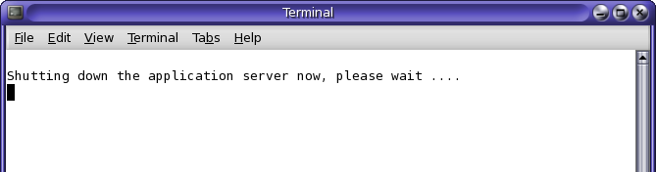

- If you have the GridTalk started in the foreground, you will see that the application is undeploying the application components and shutting down.

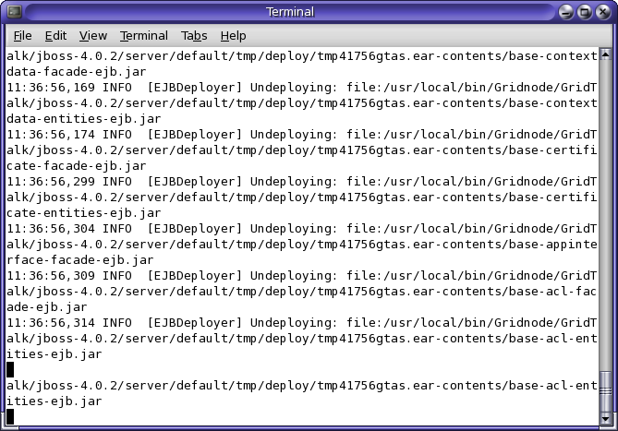

Once the shutdown completes, all GridTalk terminal windows will be closed automatically.

Maintenance of GridTalk 4.0

To uninstall GridTalk

If you don’t intend to use the existing GridTalk, you need to uninstall it by doing the following:

- Ensure that GridTalk is not started or running, if so, shut it down following the steps in section 3.2.2.

- Go to the GridTalk folder on your Desktop, and double-click the Uninstall_GridTalk shortcut icon. The Uninstall GridTalk window shows up.

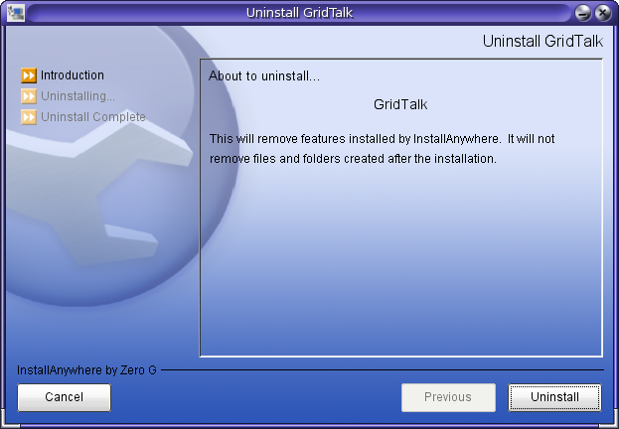

- Click Uninstall. The uninstallation process will begin.

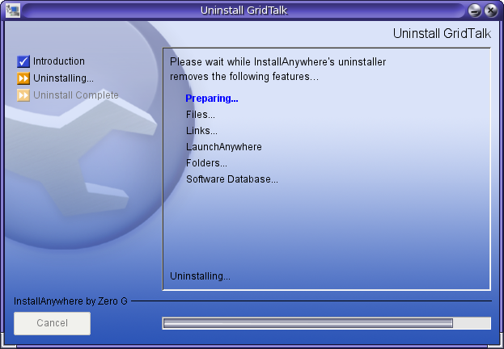

- Once the process has ended, you will be informed of the summary that the installer is unable to remove some files that you have to remove manually from the installed directory.

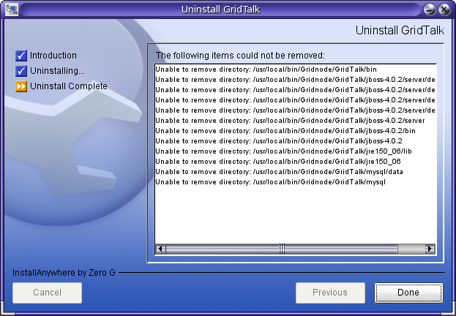

- Once GridTalk 4.0 has been successfully removed, click Done to end the installer.

To re-install GridTalk

- Download the new GridTalk 4.0 installer available for your platform to your directory.

- Double-click to run the GridTalk4.0.x_jBoss_solaris_<processor>.sh, which has been saved in your directory.

- Repeat the same procedure as described in Chapter 3.

